**Introduction:**

The Starbucks Reserve Roastery in Downtown Chicago is a notable tourist destination, recognized as the largest Starbucks in the world. Its exclusive products and experiential design attract visitors from across the globe. Since its opening day in November 2019, which welcomed over 10,000 guests (Lurye, 2019), the Reserve has maintained a high volume of foot traffic. Despite its popularity, one key business consideration remains: how do external factors such as weather affect customer turnout and satisfaction?

This project explores the relationship between weather and customer satisfaction at the Starbucks Reserve, expanding the analysis to two other prominent Chicago restaurants: Café Con Leche and Upstairs at the Gwen. These restaurants represent a mix of upscale and casual dining, allowing us to generalize insights across different experience types. The overarching goal is to assess whether weather conditions influence customer ratings, and if satisfaction patterns vary by restaurant type or location.

**Data:**

This study utilizes two primary data sources collected over a two-year period from April 1, 2023, to April 1, 2025. The first dataset includes restaurant review data scraped from OpenTable using Selenium. Reviews were gathered from three locations: Starbucks Reserve, Café Con Leche, and Upstairs at the Gwen. For each review, the date of the dining experience and the star rating were extracted. The data was filtered to include only reviews within the study’s date range and was labeled with the respective restaurant name to enable comparison.

The second dataset consists of historical weather data for Chicago, Illinois, obtained from Visual Crossing Weather. This dataset contains daily measures such as average temperature, total precipitation, wind speed, and a general weather description (e.g., sunny, cloudy, rainy). This weather data was then merged with the review dataset based on the review date, creating a comprehensive dataset that pairs each dining experience with the corresponding day’s weather conditions.

The final merged dataset used for analysis includes the following columns: review date, star rating (converted from text to a numeric float), restaurant location, average daily temperature in Fahrenheit, daily precipitation in inches, average windspeed in miles per hour, and a general weather descriptor. These variables allowed for various types of statistical and machine learning analyses to explore relationships between weather, restaurant type, and customer satisfaction.

**Analysis:**

The analysis section of this report addresses three key research questions related to weather, temperature, and restaurant location as potential drivers of customer satisfaction, as measured by star ratings. To analyze these relationships, a combination of descriptive statistics, visualizations, hypothesis testing, and regression models were used.

For the first research question, whether general weather conditions impact customer satisfaction, I grouped reviews by weather condition categories such as sunny, cloudy, and rainy. A bar chart was used to visualize the average customer ratings for each category. To statistically test for differences in ratings, a one-way ANOVA was performed. The resulting p-value of 0.837 indicated that there was no statistically significant difference in satisfaction between different weather conditions. This suggests that while weather may influence consumer turnout, it does not strongly influence satisfaction once a customer dines at the restaurant.

The second question explored whether temperature could be used to predict customer ratings. A scatter plot was created to visualize the relationship between average daily temperature and star rating, which appeared to show no clear trend. A Shapiro-Wilk test was then conducted on the residuals from the linear regression model to check for normality, with results suggesting the residuals were not normally distributed. Three regression models were implemented, Linear, Ridge, and Lasso, to predict ratings using average temperature. All models yielded nearly identical R² scores around 0.0003, indicating that temperature does not meaningfully explain variations in customer satisfaction. These results were expected based on the scatterplot, reinforcing the idea that temperature alone is not a useful predictor in this context.

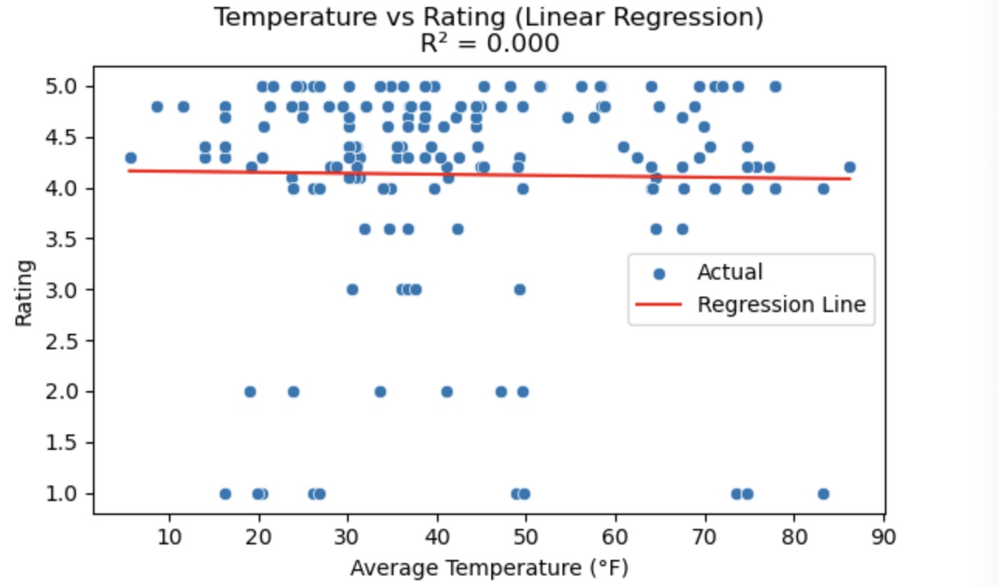

The third and final question examined whether customer satisfaction differed by restaurant location. Ratings were grouped by location and visualized using a box plot, showing visible differences in rating distributions between Starbucks Reserve, Café Con Leche, and Upstairs at the Gwen. A one-way ANOVA test was performed to assess whether these differences were statistically significant. The results showed an F-statistic of 10.059 and a p-value less than 0.001, indicating a statistically significant difference in average ratings across the three locations. This supports the hypothesis that customer satisfaction is influenced by restaurant experience and branding, with certain venues consistently receiving higher ratings.

Together, these three analyses provide a well-rounded look at external and internal factors that may affect customer satisfaction. While weather and temperature showed minimal influence, location played a significant role. These findings offer actionable insights for businesses evaluating site-specific performance or exploring location expansion.

**Conclusion:**

This project aimed to evaluate how weather conditions and restaurant location influence customer satisfaction based on OpenTable reviews from three Chicago restaurants over a two-year period. Through statistical testing and machine learning models, we found that while general weather conditions and daily temperature do not significantly predict or affect customer star ratings, the restaurant location itself does. Specifically, one or more of the restaurants consistently received higher ratings, and this difference was found to be statistically significant.

The results highlight that external factors like weather may not have as much impact on satisfaction as previously assumed, particularly when it comes to high-traffic or experience-driven venues like the Starbucks Reserve. Instead, factors intrinsic to the restaurant, such as its service, ambiance, and branding, likely play a much larger role in shaping customer perception. These insights are particularly valuable for restaurant managers and business analysts looking to understand satisfaction drivers beyond internal operations.

While the models and analyses presented in this report offer useful findings, they are not without limitations. The dataset is constrained by the review platform (OpenTable), the limited timeframe, and the assumptions made when linking weather data by date alone. Additionally, customer reviews are inherently subjective and can be influenced by many unmeasured variables. Future research can enhance this analysis by incorporating more detailed customer sentiment, additional restaurant locations, or broader environmental data like local events or holidays.

Work Cited

Lurye, S. (2019). Thousands visit first day of world’s largest Starbucks Reserve Roastery in Chicago. Eater Chicago. <https://chicago.eater.com/2019/11/18/20970480/thousands-visit-first-day-worlds-largest-starbucks-reserve-roastery-chicago-intel>

OpenTable (2025). Restaurant listings. [www.opentable.com](http://www.opentable.com)

Visual Crossing Weather. [www.visualcrossing.com](http://www.visualcrossing.com)